

Practices for Secure Software Report

Table of Contents
Document Revision History 3
Client 3
Instructions 3
Developer 4
1. Algorithm Cipher 4
2. Certificate Generation 4
3. Deploy Cipher 4
4. Secure Communications 4
5. Secondary Testing 4
6. Functional Testing 4
7. Summary 4
8. Industry Standard Best Practices 4

Document Revision History

Version | Date | Author | Comments
1.0 | 6/22/2026 | Elizabeth Hardegen

Client



Instructions

Submit this completed practices for secure software report. Replace the bracketed text with the relevant information. You must document your process for writing secure communications and refactoring code that complies with software security testing protocols.

- Respond to the steps outlined below and include your findings.
- Respond using your own words. You may also choose to include images or supporting materials. If you include them, make certain to insert them in all the relevant locations in the document.
- Refer to the Project Two Guidelines and Rubric for more detailed instructions about each section of the template.

Developer
Elizabeth Hardegen

Algorithm Cipher

- Overview of Encryption Algorithm Cipher
The algorithm cipher I recommend for Artemis Financial would be the AES-256 in Galois/Counter Mode. AES is one of the most commonly used encryption standards and is also trusted by governments, many businesses, and financial organizations to help protect sensitive information. AES-256 uses a 256-bit key, which will provide a strong level of security and will make it computationally impractical for attackers to break through with brute-force attacks. GCM mode will also provide authenticated encryption, which means that it not only encrypts the data but will also help verify that the information has not been tampered with or changed. This makes the AES-256 GCM an excellent choice for protecting both the customer financial information and any archived records.
- Hash Functions and Bit Levels of Cipher
The Hash functions are used to help verify the integrity of encrypted data. For this project, SHA-256 can be used to generate a checksum that will function as a digital fingerprint for a file or message. If the original data is altered in any way , the hash value will also change, making it easier to detect if the data was tampered with. Additionally, AES-GCM also includes authentication that will help verify the integrity of encrypted data. AES supports key sizes of 128, 192, and 256 bits, but using the 256-bit key gives the strongest level of protection since it increases the number of possible key combinations. This will make it significantly more secure than older encryption standards like DES, which used a smaller key size and is also not considered secure anymore.
- Use of Random Number, Symmetric Keys, and Non-Symmetric Keys
Having random numbers has a vital role in encryption because they are used to help generate secure keys as well as other cryptographic values. Additionally, using secure random number generators helps make sure that keys can not be easily predicted by attackers.
AES is a symmetric encryption algorithm, which means that the same key is used for both the encryption and decryption. Symmetric encryption is not only efficient but is also great for protecting substantial amounts of data. Asymmetric encryption methods like RSA uses a private and public keys. Although it is generally slower than symmetric encryption, it is helpful for secure communication, digital certificates, and key exchange. Symmetric and asymmetric encryption are both important because they work together to help protect data and communications.
- History and Current State of Encryption Algorithms
Encryption methods have greatly improved as technology has advanced over time and the older security methods have become vulnerable. Algorithms like DES were considered secure at one time, but they are no longer strong enough to protect sensitive information due to their smaller key sizes. Older hash functions like MD5 also became outdated because attackers are able to create collisions that weaken their effectiveness. Today, encryption focuses on stronger algorithms and authenticated encryption methods like AES-GCM. Modern encryption standards are designed to protect both the integrity of data as well as confidentiality, which helps prevent unauthorized access in addition to detecting any tampering or altering of data. For Artemis Financial, implementing AES-256 GCM and SHA-256 meets the current industry security standards like FIPS 197 and provides a very high level of security to get sensitive client data/

Certificate Generation
Insert a screenshot below of the CER file.

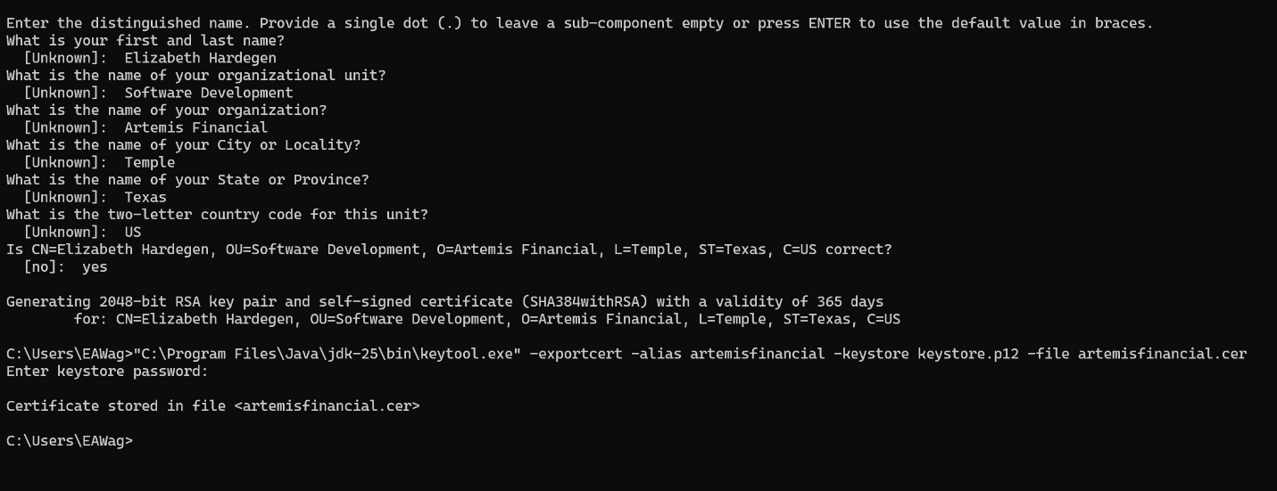
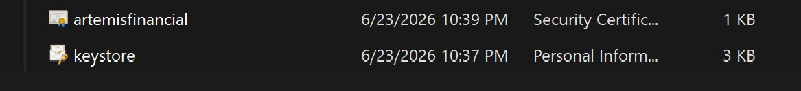

Deploy Cipher
Insert a screenshot below of the checksum verification.

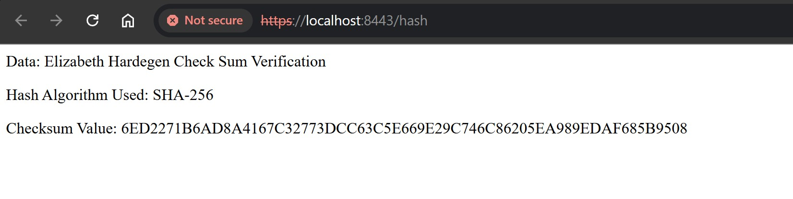

Secure Communications
Insert a screenshot below of the web browser that shows a secure webpage.


Note: The browser shows “Not Secure” because I am using a self-signed certificate that I generated for my project, not one issued by a trusted Certificate Authority (CA). So even though the browser does not trust the certificate, the application is still using the HTTPS to encrypt communication between the browser and server. Below, I have included a screen shot of the certificate.
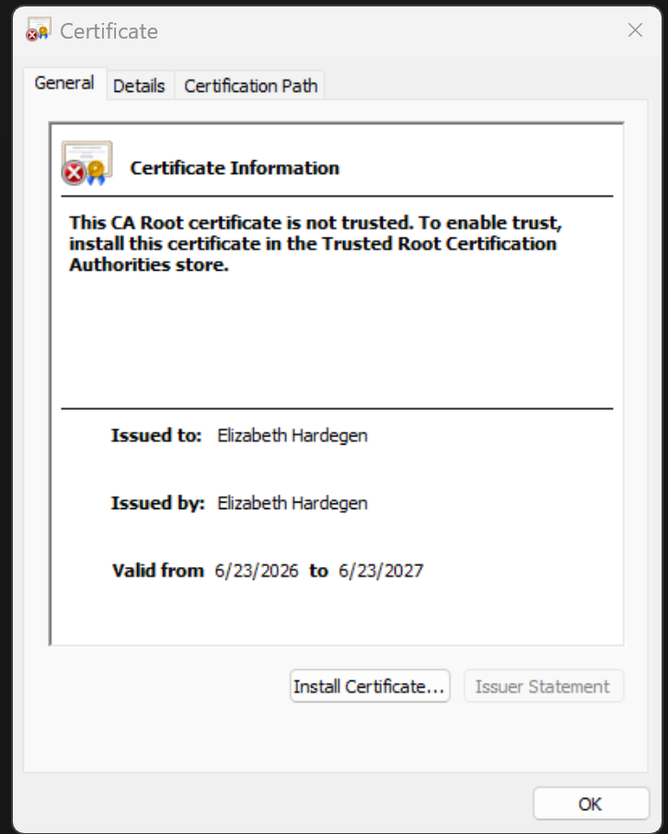

Secondary Testing
Insert screenshots below of the refactored code executed without errors and the dependency-check report.
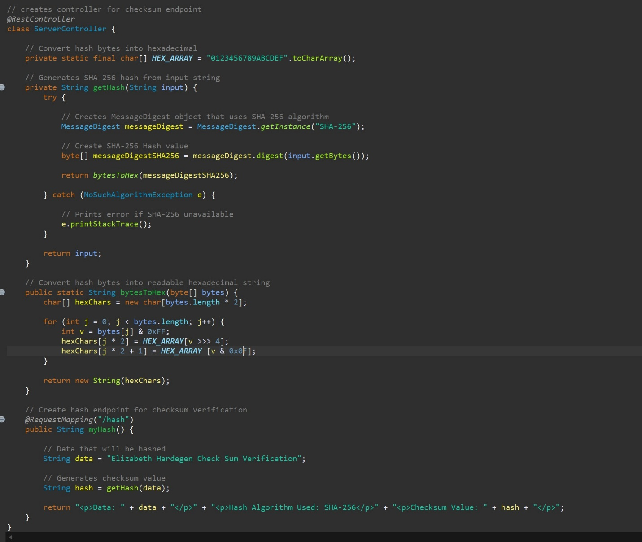

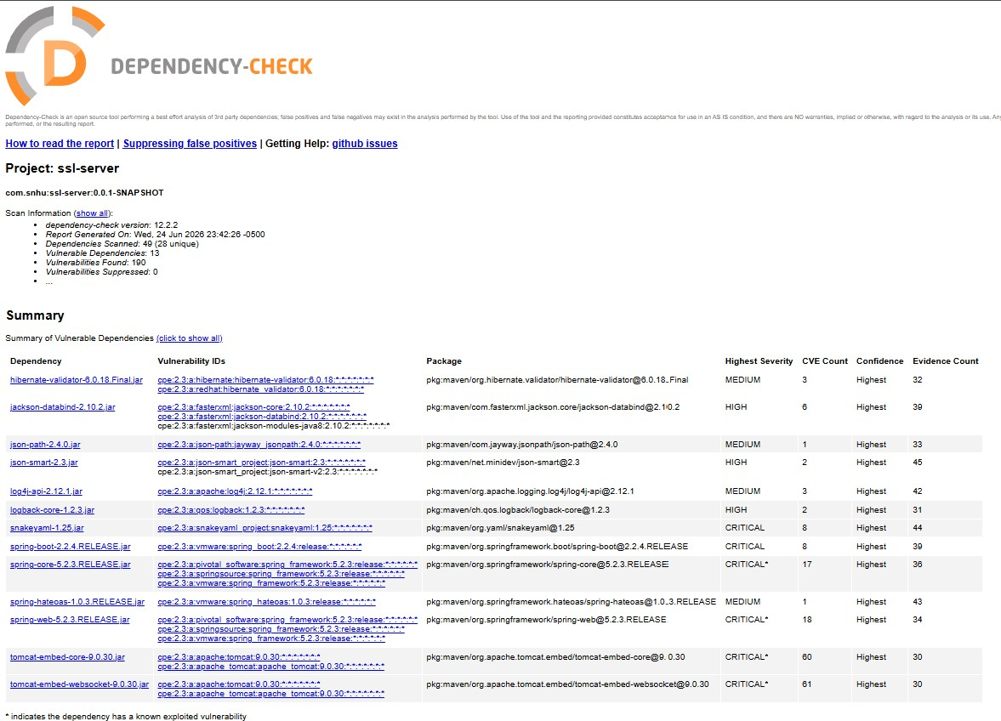

Functional Testing
Insert a screenshot below of the refactored code executed without errors.

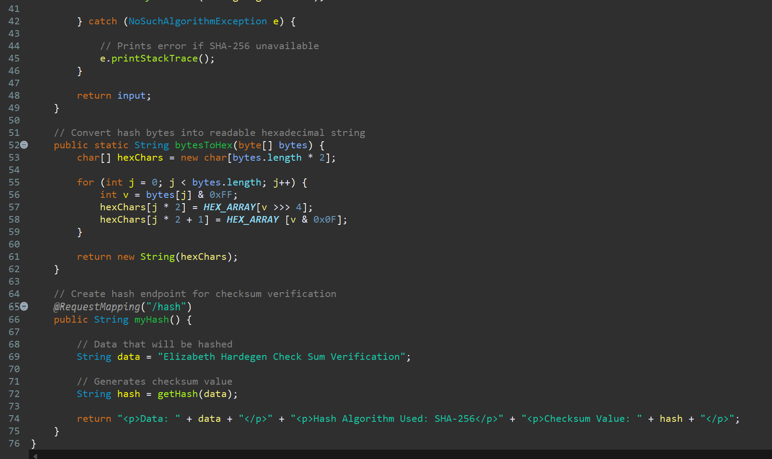
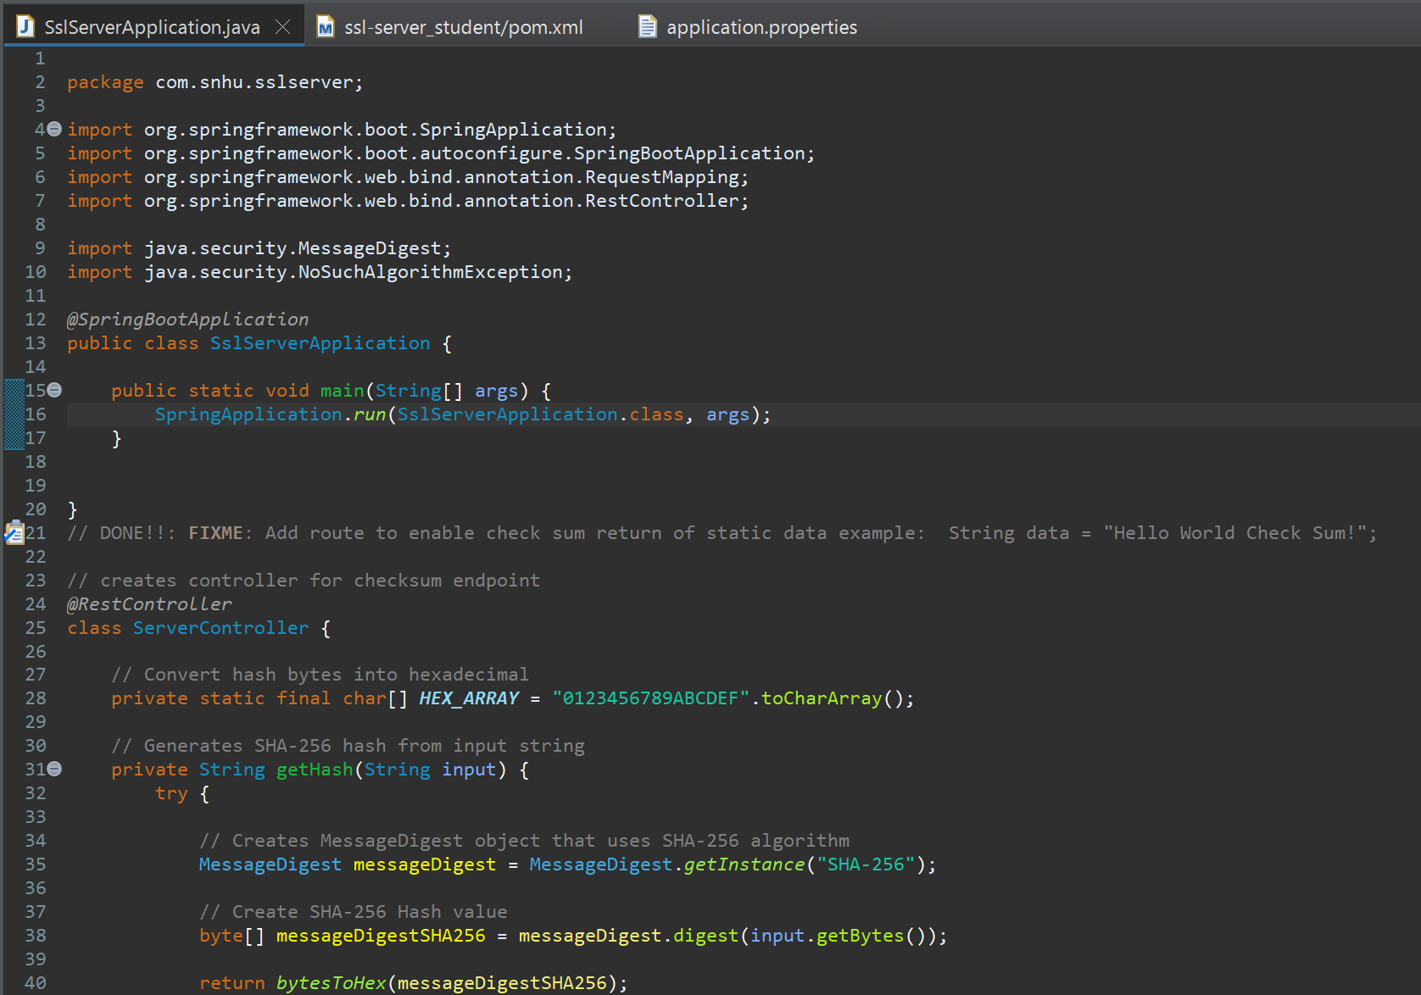
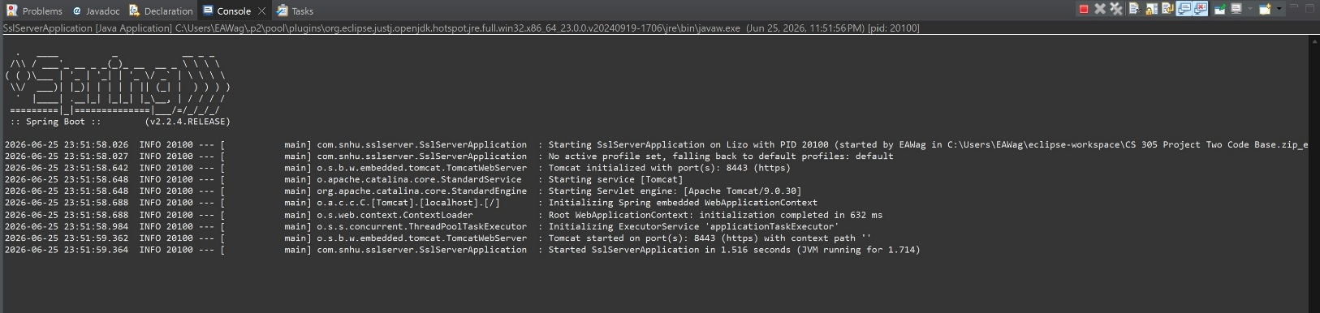

Summary

Throughout this project, I followed the vulnerability assessment process by first reviewing the application, finding security weaknesses, then implementing security improvements and finally testing the application after I made changes. The main security areas that were addressed when refactoring, was implementing HTTPS with a self-signed certificate, making sure to ass a SHA-256 Checksum verification to help with verifying data integrity, and creating secure communication between browser and application. After I finished refactoring the code, I tested the application to make sure it ran without errors and then used the OWASP Dependency-Check tool to verify that I did not introduce any additional security vulnerabilities after I made changes.
Too help add additional layers of security to the application I had to create and configure a self-signed certificate so that the application could communicate over HTTPS. Next, I implemented the SHA-256 checksum verification to help verify that the data had not been modified or tampered with. Finally, I then tested the application by checking that the HTTPS verification worked correctly, although because it was a self-signed certificate, the browser didn’t automatically trust it because a trusted Certificate Authority did not issue it, but it still confirmed that the checksum was successfully generated. I also ran and reviewed a dependency check to make sure that there were not any new vulnerable dependencies after I made changes. Altogether these security measures will help provide stronger protection.

Industry Standard Best Practices

Industry standard best practices are vital because they help the developers create or build secure application from the start, instead of trying to fix security issues after deployment. While working on this project, I applied these practices by using HTTPS for encrypted communication, implementing SHA-256 checksum verification for checking data integrity, and then using the OWASP Dependency check tool to identify vulnerable dependencies. For Artemis Financial, following industry standard best practices will help protect their customers’ sensitive financial information in addition to improving the security of their application. Secure coding practices will reduce the risk of data breaches, unauthorized access, and even data tampering, which will also help customers be able to trust the company. Regularly testing security and scanning for vulnerabilities will also help identify any security issues so they can be corrected before deployment. Making sure to follow these practices in development will help create a more secure and reliable application.

